**Ripple- Disability and Culturally Diverse Internship Program: 2025 Guidelines**

### About the Program

The **Ripple: Disability and Culturally Diverse Internship Program**, run in partnership by [Accessible Arts](https://aarts.net.au/) and [Diversity Arts Australia,](https://diversityarts.org.au/event/how-to-be-anti-racist-in-the-arts/) will take place across New South Wales (NSW) and Australian Capital Territory (ACT) in 2025. This initiative offers up to eight applicants who identify as both a person with disability or who is d/Deaf as well as culturally and linguistically diverse (CaLD) with networking and professional development training. This includes those who identify as people of colour, Black people, and people from migrant and refugee backgrounds.

Now in its third year, this exciting program continues to provide a unique professional opportunity with a paid internship, mentoring and training.

This 14-week program will assist the successful applicants to upskill towards expertise in access and inclusion for the creative industries and diversity sectors:

Specifically, the program includes:

* 6 weeks of Training (customised disability and cultural diversity awareness workshops) Up to 8 hrs per week x 6 weeks
* Mentorship (4 one-on-one Mentor sessions with a contemporary cultural/arts leader) 4 sessions x 1hr duration each
* Internship (8 weeks of placement at a Cultural/Arts Institution in NSW or ACT) 15hrs per week x 8 weeks

### Program Timeline

Tuesday 29 April to Thursday 5 June: **Training**  
Specialised access and diversity training with Accessible Arts and Diversity Arts Australia, Creative Plus Business, Sparkly Brains Psychology (formerly Sage Clinical Psychology), and other industry professionals. These sessions are online.  
(8 hours per week x 6 weeks)

Monday 9 June to Friday 22 August: **Internship placement**   
(15 hours per week x 8 weeks)

Thursday 28 August 2025: Wrap Up Session & **Graduation**  
(In-person event, including paid travel time to attend a Wrap Up Session and Graduation Ceremony in Sydney)

**Below is a breakdown of duration and payment structure for the Training element of the program, and the Intern Placement of the Program. You are paid for both parts.**

### Training Structure

You will be paid for all training hours.

The training runs across April-June 2025, prior to the placement.

The training period is 6 weeks with weekly online zoom sessions on **Tuesdays, Wednesdays and Thursdays**. The training can be up to 8 hours of training per week, including the facilitated online training sessions, prep, self-directed tasks and follow-up resources.

The selected applicants will be paid $30 per hour plus paid the statutory superannuation rate for the 6 weeks of training.

8 hrs x 6 weeks = a total of 48 hours of paid training.

You will be paid for the interning period as well. This is explained below.

### Internship Structure

This is an exciting opportunity to gain valuable insights into the kinds of organisations and work available in the arts and cultural sector, whilst forming connections as emerging creative sector workers.

The Internship is 15hrs of work per week, for 8 weeks. That is a total of 120 hours of paid placement.

The Internship period commences June 2025, and must be completed by mid-August 2025.

The selected interns will be paid $30 per hour plus paid the statutory superannuation rate, for the total 8 weeks of placement. In-person interning is generally preferred; however, hybrid placements can also be arranged in discussion with the intern and Host Organisation.

The leading arts and cultural institutions offering a placement are:

* [4A Centre for Contemporary Asian Art](https://aus01.safelinks.protection.outlook.com/?url=https%3A%2F%2F4a.com.au%2F&data=05%7C01%7Crmusgrove%40aarts.net.au%7C3d19a9da7005483d414508db50f95c49%7C9ade19cb88ec45ed83933bef0334a596%7C0%7C0%7C638192804150220159%7CUnknown%7CTWFpbGZsb3d8eyJWIjoiMC4wLjAwMDAiLCJQIjoiV2luMzIiLCJBTiI6Ik1haWwiLCJXVCI6Mn0%3D%7C3000%7C%7C%7C&sdata=OpqkW2rcotwLfC%2FeD9CzdRoTEkBTKNZNvGA3iRejWPw%3D&reserved=0)
* [APRA AMCOS](https://aus01.safelinks.protection.outlook.com/?url=https%3A%2F%2Fwww.apraamcos.com.au%2F&data=05%7C01%7Crmusgrove%40aarts.net.au%7C3d19a9da7005483d414508db50f95c49%7C9ade19cb88ec45ed83933bef0334a596%7C0%7C0%7C638192804150220159%7CUnknown%7CTWFpbGZsb3d8eyJWIjoiMC4wLjAwMDAiLCJQIjoiV2luMzIiLCJBTiI6Ik1haWwiLCJXVCI6Mn0%3D%7C3000%7C%7C%7C&sdata=%2Fv0oV22dRFN5AEYyOkObPqArbZ5IurnlWQszoJ3za98%3D&reserved=0)
* [The Art Gallery of New South Wales](https://aus01.safelinks.protection.outlook.com/?url=https%3A%2F%2Fwww.artgallery.nsw.gov.au%2F&data=05%7C01%7Crmusgrove%40aarts.net.au%7C3d19a9da7005483d414508db50f95c49%7C9ade19cb88ec45ed83933bef0334a596%7C0%7C0%7C638192804150220159%7CUnknown%7CTWFpbGZsb3d8eyJWIjoiMC4wLjAwMDAiLCJQIjoiV2luMzIiLCJBTiI6Ik1haWwiLCJXVCI6Mn0%3D%7C3000%7C%7C%7C&sdata=SiB9JigezI0G8Wk3Fo1c0%2F3Mzl9OwQInB3I7lmB7yZ0%3D&reserved=0)
* [Campbelltown Arts Centre](https://c-a-c.com.au/)
* [Powerhouse Museum](https://powerhouse.com.au/visit/castle-hill)
* [The National Portrait Gallery](https://aus01.safelinks.protection.outlook.com/?url=https%3A%2F%2Fwww.portrait.gov.au%2F&data=05%7C01%7Crmusgrove%40aarts.net.au%7C3d19a9da7005483d414508db50f95c49%7C9ade19cb88ec45ed83933bef0334a596%7C0%7C0%7C638192804150220159%7CUnknown%7CTWFpbGZsb3d8eyJWIjoiMC4wLjAwMDAiLCJQIjoiV2luMzIiLCJBTiI6Ik1haWwiLCJXVCI6Mn0%3D%7C3000%7C%7C%7C&sdata=oGIwOS8jIRjgKsJXIAKSdFOHZwORk8z0B0H8DmFiVgM%3D&reserved=0)
* [UTP (formally Urban Theatre Projects)](https://aus01.safelinks.protection.outlook.com/?url=https%3A%2F%2Futp.org.au%2Fabout&data=05%7C01%7Crmusgrove%40aarts.net.au%7C3d19a9da7005483d414508db50f95c49%7C9ade19cb88ec45ed83933bef0334a596%7C0%7C0%7C638192804150220159%7CUnknown%7CTWFpbGZsb3d8eyJWIjoiMC4wLjAwMDAiLCJQIjoiV2luMzIiLCJBTiI6Ik1haWwiLCJXVCI6Mn0%3D%7C3000%7C%7C%7C&sdata=%2BatNHj3wdyEuUOzPo6avKWRfBAikhmVCD4THUG1cRUs%3D&reserved=0)

While we will endeavour to accommodate preferences, all placements will be at the discretion of the participating arts organisations.

**What areas will the interns work in?**

The internships will be in a variety of creative and technical areas depending on the arts and cultural organisation each intern is placed within. There will be a focus on Accessibility and Inclusion practices within the Organisation. Areas include marketing, curatorial, production, front of house, arts administration, public programs, writing, producing, and editing within music, visual arts, theatre and publishing. A work program will be developed based on the skills and interests of each participant, alongside the opportunities and requirements of the organisation.

### Mentorship Structure

Over four months (May–August 2025), participants will be connected with Mentors, and provided with 4 one-on-one sessions of mentoring. These sessions can be in-person, online or hybrid. Each session is 1-hour in length.

The purpose of the mentoring is to provide guidance, support, and industry insights, helping the mentee navigate professional challenges and opportunities. In the application process, you will be able to write up to 3 preferences of mentors from the list provided.

**The mentoring includes:**

* Skill-sharing – Helping the mentee develop key industry skills.
* Networking – Connecting the mentee to relevant people and opportunities.
* Coaching & Guidance – Offering career advice and insights based on your experiences.
* Capacity Building – Helping mentees understand and apply accessibility and equity principles.

**What it is?**

* Co-designed between the mentor and mentee
* 4 structured and facilitated sessions with your mentor.
* Goal-orientated check-ins across the program
* Potentially some self-directed tasks

**What it isn’t?**

* Counselling or Professional Therapy.
* Additional supports are available externally ([Click here for a List of External Support providers](https://www.dropbox.com/scl/fi/y9113lb20bdkahgmyaqta/External-Supports-List.docx?rlkey=az7ixcyz5js8c9hwjw3qpxd67&st=vmzegn9k&dl=0))

There are 2 scheduled dates for your one-on-one mentoring. These are:

* Thursday 8 May 2025 (Your first mentoring session)
* Thursday 5 June 2025

The specific times are TBC at a later date.

The remaining mentoring sessions will be coordinated directly between you and your mentor to allow for flexibility, with support available from Accessible Arts and Diversity Arts Australia if needed.

### Eligibility Criteria

**Applicants must:**

* Reside in New South Wales or Australian Capital Territory
* Identify as being d/Deaf or a person with Disability, and
* Identify as being Culturally and Linguistically Diverse (CaLD).
* Be over 18 years of age at the time of application.
* Must be available during the mentioned program dates

Applications are warmly encouraged from people with all levels of previous experience, including those new to the workforce.

**Assessment Criteria:** The applicant demonstrates...

* Previous engagement or presently seeking career opportunities in the arts and cultural sector.
* Experience at any level in the arts and/or cultural industry.
* A proactive approach to completing the program.
* Interest and enthusiasm as an emerging cultural or creative sector worker
* Interested in disability, neurodiversity and racial justice discourse
* Ability to work effectively as part of a team and independently
* Competency in Microsoft Office applications & Zoom Meeting Platform
* Nurturing some form of creative/arts/crafts practice (desirable but not essential)

**What does Person with Disability include?**

Anyone with sensory or physical conditions, learning disability, chronic illnesses, mental health conditions or who is neurodivergent.

**What does Culturally and linguistically diverse include?**

Those who identify as culturally diverse, people of colour, Black, people from migrant and refugee backgrounds.

### Partnering Host Organisations

Below is a list of our partnering organisations. Take note of their locations and visit their websites to learn more about the work that they do and how it may align with your goals and interest areas.

While our partner organisations will endeavour to meet participants' access needs, there may be some limitations in certain circumstances. We encourage applicants to reach out to Accessible Arts with any questions about access requirements before the application deadline.

**4A Centre for Contemporary Asian Art – Haymarket, NSW**

4A Centre for Contemporary Asian Art champions the practices of Asian artists and elevates cross-cultural dialogues between Australia and Asia.

4A Centre for Contemporary Asian Art (4A) is an independent not-for-profit organisation based in Sydney, Australia. Since 1996, 4A has fostered excellence and innovation in contemporary culture through the commissioning, presentation, documentation and research of contemporary art. Our program is presented throughout Australia and Asia, where we ensure that contemporary art plays a central role in understanding and developing the dynamic relationship between Australia and the wider Asian region.

**Location:** 181-187 Hay Street, Haymarket 2000 NSW (Internship- Online)

**Website**: [4A Centre for Contemporary Asian Art](https://aus01.safelinks.protection.outlook.com/?url=https%3A%2F%2F4a.com.au%2F&data=05%7C01%7Crmusgrove%40aarts.net.au%7C3d19a9da7005483d414508db50f95c49%7C9ade19cb88ec45ed83933bef0334a596%7C0%7C0%7C638192804150220159%7CUnknown%7CTWFpbGZsb3d8eyJWIjoiMC4wLjAwMDAiLCJQIjoiV2luMzIiLCJBTiI6Ik1haWwiLCJXVCI6Mn0%3D%7C3000%7C%7C%7C&sdata=OpqkW2rcotwLfC%2FeD9CzdRoTEkBTKNZNvGA3iRejWPw%3D&reserved=0)

**Timeline of internship**: June – August 2025 (ideally 09 June – 22 August)

**The scope of the Internship Project**:

The Ripple intern will work with 4A and Chau Chak Wing Museum staff, to ensure an upcoming exhibition has materials that are inclusive and accessible. This includes working with curators and editors to produce Easy English / translated exhibition materials, preparing an accessible exhibition room sheet, producing an access guide for the onsite exhibition and the exhibition website, producing alt-text or voice-overs for images and graphics; and any other recommendations that will make the exhibition-going experience more welcoming to people from all backgrounds.

This will be particularly interesting/challenging given that the subject matter of the exhibition revolves around Chinese contemporary internet language and is anticipated to be very visual heavy.

**Special Note for 4A Centre for Contemporary Asian Art:**

From 06 June to 03 August 2025, two exhibitions will be shown at 4A’s main gallery and 4A LAB, namely: Germinate/Propagate/Bloom by Queensland artists-duo Man & Wah; and Last Call by New York-based American artist Winnie Cheung. Ripple intern will not work on these exhibitions.

4A’s building elevators will undergo a much-needed replacement and the capital work is confirmed to take place from 04 August to 26 October. This means that the office will not be accessible during this period, and 4A staff are anticipated to work from home, or from a project site.

**APRA AMCOS – Ultimo, NSW**

APRA AMCOS is a member-owned organization that represents over 119,000 songwriters, composers, and music publishers. They license organisations to play, perform, copy, record, or make available music, and then distribute the royalties to their members. APRA AMCOS ensures that music creators are fairly compensated for the use of their work, both locally and internationally

**Location:** 16 Mountain St, Ultimo NSW

**Website:** [APRA AMCOS](https://aus01.safelinks.protection.outlook.com/?url=https%3A%2F%2Fwww.apraamcos.com.au%2F&data=05%7C01%7Crmusgrove%40aarts.net.au%7C3d19a9da7005483d414508db50f95c49%7C9ade19cb88ec45ed83933bef0334a596%7C0%7C0%7C638192804150220159%7CUnknown%7CTWFpbGZsb3d8eyJWIjoiMC4wLjAwMDAiLCJQIjoiV2luMzIiLCJBTiI6Ik1haWwiLCJXVCI6Mn0%3D%7C3000%7C%7C%7C&sdata=%2Fv0oV22dRFN5AEYyOkObPqArbZ5IurnlWQszoJ3za98%3D&reserved=0)

**The scope of the Internship Project**:

As part of the Ripple program the intern will join APRA AMCOS working primarily with the People and Culture team.

* **Introduction and Orientation:** The intern will receive an office tour, meet key team members, and learn about APRA AMCOS’s mission and structure, with a focus on the People and Culture team.
* **Employee Experience**: assist in planning employee engagement activities having the opportunity to provide feedback on improvement with accessibility
* **Cross-Team Collaboration:** have opportunities to connect with other teams across the business to gain a broader understanding of the organisation operations and provide insights and feedback.
* **Project Support and Content Creation:** can support ongoing projects and create content for internal communications, ensuring accessibility considerations are included.
* **Reflection and Feedback:** At the end of the program, the intern will be given the opportunity to provide feedback of their experience, in a feedback session

**Art Gallery of New South Wales – Metro Sydney, NSW**

The Art Gallery of New South Wales is one of Australia’s flagship art museums and the state’s leading visual arts institution. As the state art museum, it champions artists and aims to serve the widest possible audience as a centre of excellence for the collection, preservation, documentation, interpretation and display of Australian and international art, and a forum for scholarship, art education and the exchange of ideas.

**Location:** Art Gallery Road, The Domain, Sydney NSW 2000, Australia

**Website:** [The Art Gallery of New South Wales](https://aus01.safelinks.protection.outlook.com/?url=https%3A%2F%2Fwww.artgallery.nsw.gov.au%2F&data=05%7C01%7Crmusgrove%40aarts.net.au%7C3d19a9da7005483d414508db50f95c49%7C9ade19cb88ec45ed83933bef0334a596%7C0%7C0%7C638192804150220159%7CUnknown%7CTWFpbGZsb3d8eyJWIjoiMC4wLjAwMDAiLCJQIjoiV2luMzIiLCJBTiI6Ik1haWwiLCJXVCI6Mn0%3D%7C3000%7C%7C%7C&sdata=SiB9JigezI0G8Wk3Fo1c0%2F3Mzl9OwQInB3I7lmB7yZ0%3D&reserved=0)

**The scope of the Internship Project:** The intern will explore a range of practices at the Art Gallery of NSW, and be involved in specific projects. The interns may work across curatorial, accessibility and public programming, to gain a range of experience and skills that aid emerging arts workers, with a focus on Inclusion and Diversity.

**Campbelltown Arts Centre – Campbelltown, NSW**

Located on Dharawal land in the heart of South West Sydney, Campbelltown Arts Centre (CAC) is a leading cultural facility of Campbelltown City Council. CAC is recognised for its quality and innovative programming where collaboration is central to the way it works with artists, communities, and partners to present new work that tells relevant stories, challenges perceptions and amplifies diverse perspectives.

We respect and embrace diverse cultural practices and knowledge, take risks and encourage experimentation. Committed to nurturing the next generation of artists, we embed skills development, facilitate creative pathways and encourage bold and innovative work. We advocate for artists and the creative sector in Western Sydney, fostering contemporary creative practices through multidisciplinary programs.

This placement is especially encouraging of an applicant with ties to Western Sydney.

**Location:** 1 Art Gallery Road, Campbelltown New South Wales 2560

**Website:** [Campbelltown Arts Centre](https://c-a-c.com.au/)

**The scope of the Internship Project:**

An opportunity to gain hands-on experience across multiple areas of arts administration, curation, education, public programming and audience engagement. As an intern, you’ll collaborate with curatorial, education, public programming, engagement and visitor experience teams, gaining invaluable insights into how a leading contemporary arts centre operates. From supporting exhibitions and public programs to assisting with artistic projects and community engagement this internship offers a comprehensive introduction to the creative industries.

**National Portrait Gallery– Parkes, ACT**

The National Portrait Gallery (NPG) is a National Cultural Institution dedicated to exploring and sharing the evolution of Australian identity through portraiture. Guided by our vision to reflect the face of Australia, we engage with audiences onsite, online, and offsite nationwide. We prioritise First Nations peoples' knowledge, perspectives, and self-determination in our methodologies, aiming to convey complex stories through the accessible art form of portraiture. Our programming fosters creativity and ensures the longevity of the narratives behind the art. Every artist and sitter in our collection contributes to the collective narrative of national identity.

**Location:**  National Portrait Gallery, King Edward Terrace, Parkes ACT 2600, on the lands of the Ngunnawal and Ngambri peoples.

**Website:** [The National Portrait Gallery](https://aus01.safelinks.protection.outlook.com/?url=https%3A%2F%2Fwww.portrait.gov.au%2F&data=05%7C01%7Crmusgrove%40aarts.net.au%7C3d19a9da7005483d414508db50f95c49%7C9ade19cb88ec45ed83933bef0334a596%7C0%7C0%7C638192804150220159%7CUnknown%7CTWFpbGZsb3d8eyJWIjoiMC4wLjAwMDAiLCJQIjoiV2luMzIiLCJBTiI6Ik1haWwiLCJXVCI6Mn0%3D%7C3000%7C%7C%7C&sdata=oGIwOS8jIRjgKsJXIAKSdFOHZwORk8z0B0H8DmFiVgM%3D&reserved=0)

**The scope of the Internship Project:**

The Ripple Internship is within the Access and Learning section of the NPG, which focuses on delivering education experiences, visitor services, access initiatives, and public programs for diverse audiences. The Ripple Intern will collaborate with other sections and meet individuals from External Relations, Digital Production, and Corporate Services. For the period of June to August, The Ripple Internship project work will focus on the development and delivery of:

Virtual Highlights Tour Delivery: A casual online program to a regular audience seeking to connect with portraits and hear stories and information.

* Develop and deliver a 30-minute online program for approximately 20+ connection points.
* Select, research, and present 3 portraits from the Collection or special exhibitions.
* Facilitate interactive discussions with the online audience.

Late Nights Project Team Member: The Gallery’s annual event creating a safe space for diversity, where everyone feels celebrated and welcome as they connect with portraiture, art, creativity and each other.

* Advise on marketing strategies to diverse audiences.
* Create inclusive and sensory-friendly spaces.
* Contribute ideas for event activations and potential performers.

Disability Inclusion Action Plan Working Group Member: The NPG is commencing work on reviewing and setting new goals against each outcome area.

* Participate in reviewing and setting new goals for the NPG's Disability Inclusion Action Plan.
* Identify gaps and opportunities for the years 2026 – 2028.
* Thom Roberts Programming: Thom works with Studio A, a supported studio creating professional pathways for artists with lived experience of intellectual disability. This is the first solo exhibition of his work. · Support the delivery team for the exhibition The Immersive World of Thom Roberts
* Assist with material preparation and visitor experience.
* Provide feedback for future programs.
* National Photographic Portrait Prize Learning Resource: The National Photographic Portrait Prize is an annual exhibition reflecting the distinctive vision of Australia's aspiring and professional portrait photographers and the unique nature of their diverse subjects.
* Support the Learning Facilitator in developing educational resources for school students.

**Powerhouse Museum – Castle Hill, NSW**

The Powerhouse is the largest museum group in Australia. It sits at the intersection of the arts, design, science and technology and plays a critical role in engaging communities with contemporary ideas and issues. It is custodian to more than half a million objects of national and international significance and is considered one of the finest and most diverse collections in Australia.

**Location:** 2 Green Road, Castle Hill NSW 2154

**Website**: [Powerhouse Museum](https://powerhouse.com.au/visit/castle-hill)

**The scope of the Internship Project:** the intern is likely to be involved in a variety of areas, with specific focus on Front of House experience, and Community Engagement programming. The intern may also be involved in some curatorial work.

**UTP – Bankstown, NSW**

Utp is a unique commissioning and producing organisation. We make long-term investments in collaborations with artists and communities from outside the dominant culture to give form to extraordinary ideas. We never do this alone, working with an exceptional set of partners to co-produce a year-round program of performance, dance, visual art, learning and community-led projects, unlike anything you have seen before.

**Location:** 5 Olympic Parade Bankstown NSW 2200

**Website**: [UTP (formally Urban Theatre Projects)](https://aus01.safelinks.protection.outlook.com/?url=https%3A%2F%2Futp.org.au%2Fabout&data=05%7C01%7Crmusgrove%40aarts.net.au%7C3d19a9da7005483d414508db50f95c49%7C9ade19cb88ec45ed83933bef0334a596%7C0%7C0%7C638192804150220159%7CUnknown%7CTWFpbGZsb3d8eyJWIjoiMC4wLjAwMDAiLCJQIjoiV2luMzIiLCJBTiI6Ik1haWwiLCJXVCI6Mn0%3D%7C3000%7C%7C%7C&sdata=%2BatNHj3wdyEuUOzPo6avKWRfBAikhmVCD4THUG1cRUs%3D&reserved=0)

**The scope of the Internship Project:** the intern is likely to be involved in a variety of areas, learning across the departments- marketing, programming, accessibility, community engagement. Community-led, and artist-led projects are fundamental to our organisation, and so too do we want this opportunity to be intern-led. We are keen to ensure the internship is fitted to the goals of the intern, having discussions on how we can best build a valuable experience for them and their focus areas.

### Access

Accessible Arts and Diversity Arts Australia will provide access support for the partnering organisations and program participants throughout the mentorship. To ensure that each participant access needs are met, you will be asked by Accessible Arts to complete a section in your application regarding your access provisions. This helps us to ensure that you can fully engage in the program and get the most out of your placement, mentoring and training. Where appropriate, participants will be encouraged to use their NDIS package (if available) to support their participation in the program.

Successful applicants and partnering organisations will be provided with Disability Confidence Training facilitated by Accessible Arts.

### How to Apply

**Applicants will be asked to provide the following information:**

* Contact Details
* Applicants must identify as being d/Deaf or a person with disability and Culturally and Linguistically Diverse (CaLD).
* An outline of any access requirements you might have.
* A CV and short bio – including examples of relevant work, volunteer, studies and/or qualifications
* List the top three organisations that you are interested in working with.
* List the top three Mentors you are interested in (or suggest a mentor).
* Answer a variety of questions around your career goals, why this is an important opportunity for you, your interest in the Inclusion and Diversity space etc.

**NOTE:** In the application form, you will be asked to select your top three preferred organisations and top three preferred mentors. While every effort will be made to match you with one of your top choices, applicants may not be paired with their first-listed organisation. The same applies to your top 3 preferred Mentors.

### Application Form

Applications can be submitted online via Survey Monkey here:   
[Apply here](https://www.surveymonkey.com/r/RVKRYKZ)

Alternative formats such as audio, or video submissions are also accepted with prior approval. **Please reach out to Accessible Arts before submitting the application in an alternative format to ensure your application is received.**

### When to Apply

Applications will open from Thursday **27 February 2025** and close at **11pm on Sunday 30 March 2025.**

### Application assessment

Applications will be assessed by a panel of Accessible Arts & Diversity Arts Australia staff, including people who identify with CaLD, and disability. The panel will consider how well the applicant aligns with the program, the partnering organisation, and the mentor, as well as relevant work experience and commitment to the program. Partnering organisations will be consulted during the review process to ensure cultural safety and access requirements can be met for the program participants.

### Additional Information

### Timeline & Key Dates

* **Applications open:** Thursday 27 February 2025
* **Applications close:** 11pm Sunday 30 March 2025
* **Outcome Notifications:** Early April 2025
* **Announcement:** Mid-April 2025
* **Training:** Tuesday 29 April – Thursday 5 June 2025
* **Internship:** Monday 9 June – Friday 22 August 2025
* **Mentorship Period:** April – August 2025
* **Wrap-up (In-person session) and Graduation:** 28 August 2025, Sydney.

**Marketing & Contract**

Successful applicants will need to sign a contract that includes additional terms and conditions based on Accessible Arts and Diversity Arts’ policies. Applicants must also give permission for Accessible Arts and Diversity Arts to promote and share the

outcomes of the Ripple: Disability and Culturally Diverse Internship Program. This may include agreeing to participate in interviews, filming, and other social media opportunities for promotional purposes.

**Program Fee**  
Each participant within the Ripple program will receive payment for attending training and across their placement at the agreed Host Organisation, inclusive of superannuation. This payment will be paid fortnightly throughout the program. The payment schedule will be outlined at the start of the program, and participants will be informed of the payment cycle.

**Program Requirements**

* **Program Completion:** Participants are required to complete the full program, including the 48 hours of training (up to 8 hours per week for 6 weeks), 120 hours of placement (15 hours per week for 8 weeks), and 4 hours on one-on-one mentoring (1 hour of 4 one-on-one mentor sessions).
* **Regular Communication:** Maintain regular communication with Accessible Arts/Diversity Arts and the partnering organisation throughout the program.
* **Mid-Program Survey:** Submit a mid-program survey.
* **End-of-Program Survey:** Complete the end of the program survey.
* **Evaluation:** be available for post-program feedback opportunities, potentially in the form of a survey, or interview.
* **Documentation of Participation:** Provide at least one photo or reel showcasing your experience during the program.

**Enquiries**

If you have any questions about your application or the Ripple: Disability and Culturally Diverse Internship Program, please email Accessible Arts:

**Email:** [info@aarts.net.au](mailto:info@aarts.net.au)

**Call:** +61 2 9251 6499.

Our team is available 10am to 5pm on Tuesdays and Thursdays for phone enquires.

This project has been assisted by the Australian Government- Department of the Prime Minister and Cabinet, and Create NSW

**Accessible Arts – Principal Funder**

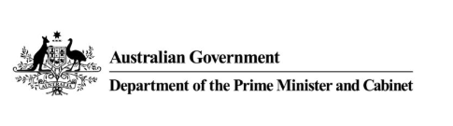  


**Partners**

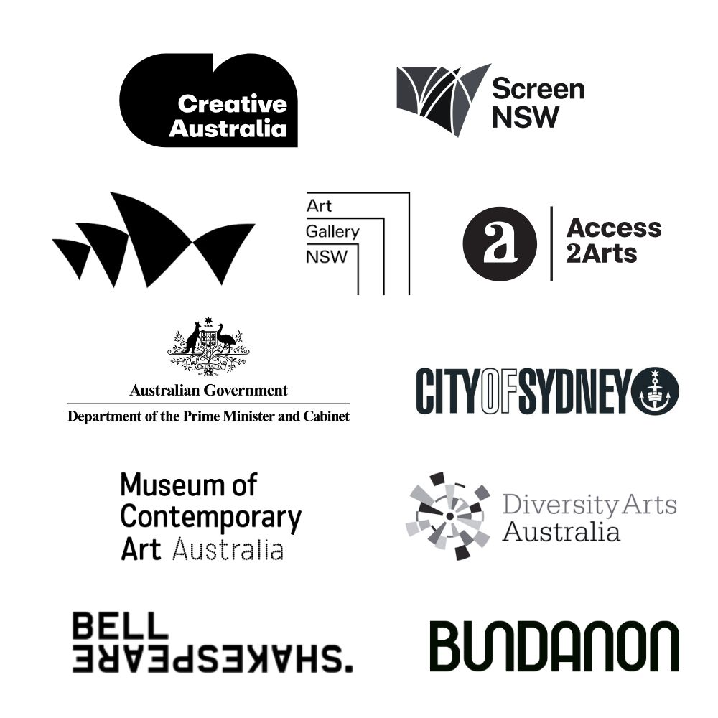

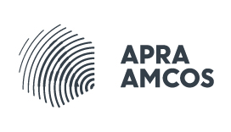

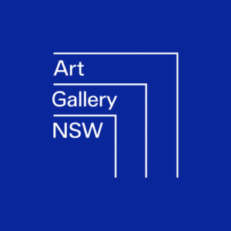

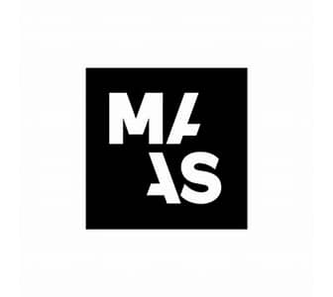









Please note, all successful applicants may be asked to complete both a Police Check and a Working with Children Check. The financial costs associated with these checks will be reimbursed by Accessible Arts.