Alternative Word Document Application for Ripple Program 2025

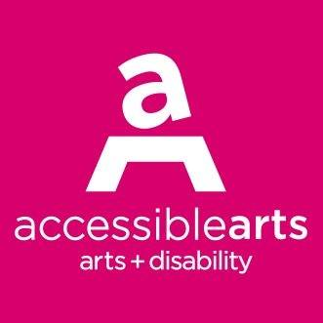

|  |
| --- |
| **Ripple: Disability and Culturally Diverse Internship Application 2025** |

### **Question Title**

#### 1. **Contact Information**

Name

Address

City

State

Postal Code

Email

Phone

Birth Date

#### 2. **Gender:**

Female

Male

Non-Binary

Other

Prefer not to say

#### 3. **Please tell us about yourself and your creative practice? Please limit your answers to 300 words max.**

#### 4. **Do you identify as any of the following (select as many as you like)**

* Culturally and linguistically diverse
* LGBTQIA+
* Person with disability
* Person who is d/Deaf
* Person with chronic illness or pain
* Person with mental health conditions
* Person living in regional NSW
* Person living in regional ACT
* None of the above
* Prefer not to answer

#### 5. **This program is for people with disability or who are d/Deaf as well as culturally and linguistically diverse (CaLD), to build skills towards being professional Access, Diversity and Inclusion consultants in the arts and culture sector. Why do you want to undertake this internship?**

#### 6. **What relevant skills and experience would you bring with you to this opportunity?**

#### 7. **What do you consider to be some of the challenges that people from Culturally and Linguistically Diverse backgrounds with disability experience? Please limit your answer to 300 words max.**

#### 8. **What is your desired outcome for participating in this program? Please list up to three goals.**

#### 9. **Do you foresee any challenges during the program? If so, please list them below.**

#### 10. **Give us an example of how you work collaboratively and independently?**

#### 11. **List computer programs you are competent with. Eg., Microsoft 365 (Word, Excel), Zoom video webinar.**

#### 12. **Can you commit your time for the workshop trainings falling on Tuesdays, Wednesdays and Thursdays between April 29 – June 5th, 2025? Understanding this might be up to a max 8hrs per week (a combination of online live workshops, prep, self-directed tasks and follow-up resources).**

Yes

No

(if answered no) comment:

#### * 13. **Identify the host organisations that you are interested in working with. You may select up to three (3) organisations.** Please note that while we will endeavor to accommodate preferences, all placements will be at the discretion of the participating arts organisations.

* **The National Portrait Gallery,** Parkes ACT (Online and In-Person internship possible but at least 60% In-Person preferred)
* **The Art Gallery of New South Wales,** Sydney NSW (Online and In-Person internship possible, but the first few days must be In-Person)
* **Urban Theatre Projects**, Bankstown NSW (Online and In-Person internship possible)
* **APRA AMCOS**, Ultimo NSW (Online and In-Person internship possible)
* **4A Centre for Contemporary Asian Art,** Haymarket NSW (Online predominantly. 4A’s building elevators will undergo a much-needed replacement and the capital work is confirmed to take place from 04 August onwards. This means that the office will not be accessible during this period, and 4A staff are anticipated to work from home, or from a project site).
* **Powerhouse Museum,** Castle Hill, NSW (In-Person and Online internship possible. A few days onsite desired)
* **Campbelltown Arts Centre, Campbelltown, NSW** (Online and In-Person internship possible, with a preference to work In-Person each week.

#### 14. **Why do you think your 3 preferences of Host Orgs are a good fit for you and your goals?** (Please limit your answer to 300 words max)

#### * 15. **Identify the Mentors you are interested in working with. You may select up to four (4) mentors, and select a minimum of 3. If you would like to suggest a mentor, please still pick 2-3 options from our list.** Please note that while we will endeavour to accommodate preferences, all placements will be at the discretion of the participating mentors.

* **Samia Sayed**
* **Verónica Barac-Gomez**
* **Bina Bhattacharya**
* **Najee Tannous**
* **Adrian Mouhajer**
* **Gabriela Green Olea**
* **Imogen Yang**
* **Tasnim Hossain**
* **Other** (please specify if you have a mentor you would like to recommend. Additionally, please share if you are already connected, or you would be seeking Accessible Arts to seek out the possibility of them mentoring.)

#### 16. **Why do you think your 3 preferences of mentors are a good fit for you and your goals?** (Please limit your answer to 300 words max)

#### * 17. **Can you commit 2 full-days a week (or equivalent) between June 6th– August 22nd 2025 for your placement?** (note: the placement must be completed by 22nd, or 25th August at its latest)

#### * 18. **If you are attending the host organisation in person, will you be able to cover your own travel cost during the internship period (June 6 – August 22 2025)?** If you are experiencing financial hardships, please contact Accessible Arts to discuss alternative arrangements.

* Yes:
* If no, please contact Accessible Arts to talk about alternative arrangements, and feel free to write here.

#### * 19. **Most of the training workshops will be done via Zoom. Have you used Zoom and are you able to participate in the workshop training using this platform?**

#### * 20. **Are you available to travel to Sydney on Thursday 28 August to attend an in-person session (approx. 10:30am-12) at the Accessible Arts Office, The Arts Exchange, Level 3/10 Hickson Rd, The Rocks NSW, and Graduation from 2 - 4pm at The Art Gallery of NSW?** Travel expenses will be covered.

#### * 21. **Outline any support and/or access requirements you may have that are relevant to your participation in this internship program.**

#### 22. **Upload your CV here**

Choose File

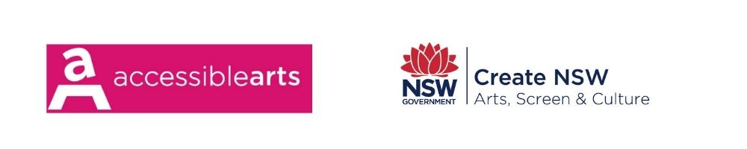

[NEW QUESTION](https://www.surveymonkey.com/create/?sm=9Wn7mfWOVpa7N28eZ1GeFupoDqF86vK6kujnhgdNoFY_3D)