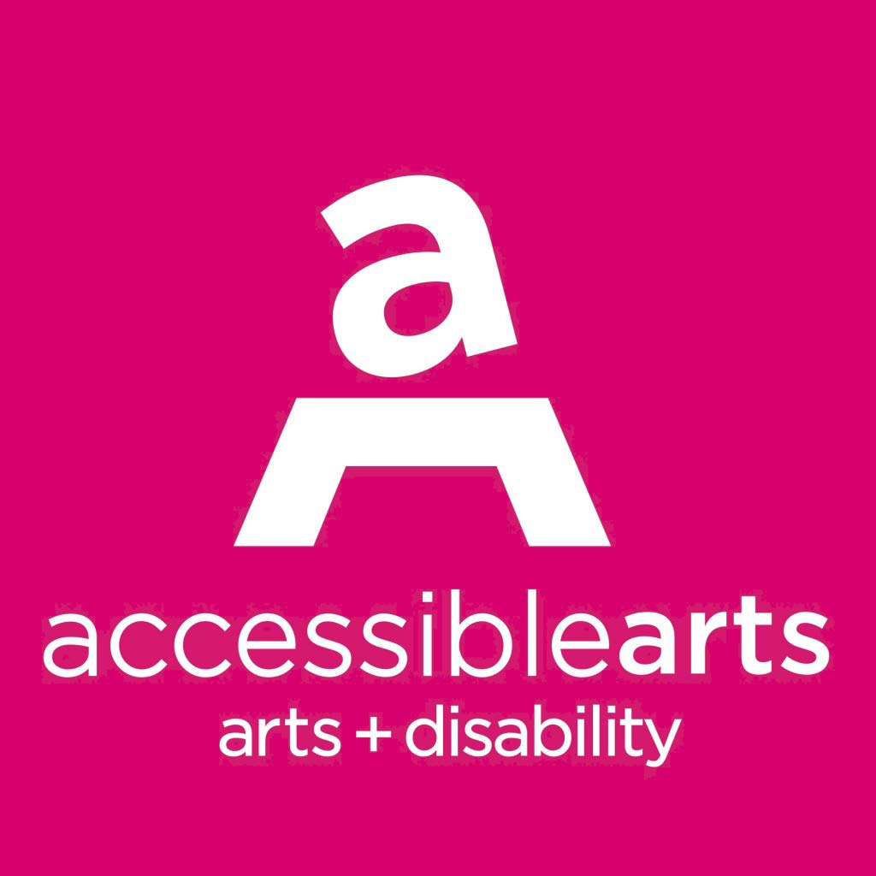
Accessible Arts
Position Description – Operations Manager
Accessible Arts is committed to equity and inclusion, and welcomes applications from people from diverse backgrounds, including people with disability or who are d/Deaf.

Details: Part-time (22.5 hours per week)
Reporting to: CEO
Reports: Office Administrator

About Accessible Arts
Accessible Arts (AArts) is the peak arts and disability organisation in New South Wales. Established in 1986, we work with and for our community to accelerate and celebrate the diverse professional, cultural and social impacts of arts and disability in NSW. We advance the rights of, and opportunities for, people with disability and/or who are d/Deaf to develop and sustain professional careers in the arts and have equitable access to arts and culture across NSW. Our vision is equity and excellence in arts, culture, and disability. More information is available online at www.aarts.net.au.
About The Position
Working closely with the CEO, the Operations Manager will oversee key operational, financial, Information Technology and Communications, and Human Resources services of a high achieving peak service organisation, within a small, committed team, located in The Rocks.
- 12 month fixed-term contract position with the possibility of renewal;
- flexible working arrangements up to 22.5 hours per week;
- Employee Assistance Program and Salary Sacrifice options;
- This position reports to and will work closely with the CEO.

Position Responsibilities
Financial Management (in collaboration with the company’s Bookkeeper and FARS committee)
- Preparation of accounts for funding applications and acquittals; and
- Assistance with annual project budgeting and planning process in consultation with the CEO and financial support services.

ICT And Property Services Support
- Oversight of IT needs and services in consultation with IT service providers;
- Oversight of the operation of the telephone system; and
- Management of lease/tenancy arrangements, including coordination of maintenance and repairs, attending tenants’ meetings and liaison with other tenants on issues of common concern, liaison with property management agent and landlord (Create NSW).

Human Resource Management
- Oversight and implementation of particular HR management strategies including recruitment, policy/practices, pay and conditions, contracts, training and development;
- Monitor, measure and report on operational and strategic HR issues, opportunities and development plans.

Risk Management
- Oversight of all insurance policies including annual renewals;
- In collaboration with the CEO, ensure all activity complies with organisational risk management and legislative requirements for quality management, health and safety, environmental policies and general duty of care; and
- Oversight of effective and timely assessment of risks to health and safety, and implementation of strategies identified to mitigate these risks.

Project management
- Assistance with preparation of grant applications and acquittals;
- Oversight of project budgets, including income and expenditure tracking;
- Oversight of all contractual agreements;
- Monitoring of project activities, including evaluation, according to the program evaluation framework; and
- Identification of opportunities that will foster the ongoing impact of projects.

Other
- Responsibility for organisation-wide record keeping practices;
- Contribute to short and long-term organisational planning and strategy;
- Drive organisational initiatives that contribute to long-term operational excellence;
- Support the CEO in reviewing organisational performance;
- Oversight of access service bookings as required (e.g. for Board meetings).

Key external relationships
Primary liaison with:
- Contracted providers of accounting, IT and computer services; and
- Property management, services and maintenance staff to maintain office facilities.

Some liaison may be required from time to time with:
- Stakeholders associated with key projects and programs, including partner organisations, people with disability and policy makers; and
- Corporate partners, sponsors, event suppliers and venues.

Selection criteria
Requirements
- High level communication skills, including excellent interpersonal skills and a collaborative management style;
- Self-motivated, detail orientated and demonstrated capacity to work autonomously and as part of small team;
- Demonstrated skills in budgeting and financial reporting;
- Experience with accounting software such as MYOB or Xero;
- Knowledge of operational ITC requirements and ability to trouble-shoot;
- Experience with third party contractual services and vendor management;
- Awareness of current HR policies and practice;
- Understanding of risk management processes;
- Ability to manage projects effectively and efficiently; and
- Qualifications in relevant discipline (e.g. Commerce, Accounting, Finance, Arts Management, Business) or equivalent professional experience.

Desirable
- Knowledge and understanding of the arts and disability sector and accessibility practices; and
- Experience in a managerial role within an arts, or other not-for-profit organisation.

Other requirements
Occasional evening and weekend work may be required to represent Accessible Arts at external events, as well as attend Accessible Arts events as required.

To apply:
The Position Description, including selection criteria along with details of how to apply can be downloaded at http://www.aarts.net.au/work-with-us/
Applicants must provide a covering letter specifically responding to the selection criteria and a copy of their CV, including contact details of two referees.
For enquiries about this position, please contact Liz Martin (CEO) on lmartin@aarts.net.au or 0409 836 634

Applications close at 9am on Monday 19 February 2024 and must be emailed to lmartin@aarts.net.au

** Position description current as of January 2024. This document will be reviewed on a regular basis and changes made to reflect changes in the requirements of the role.

