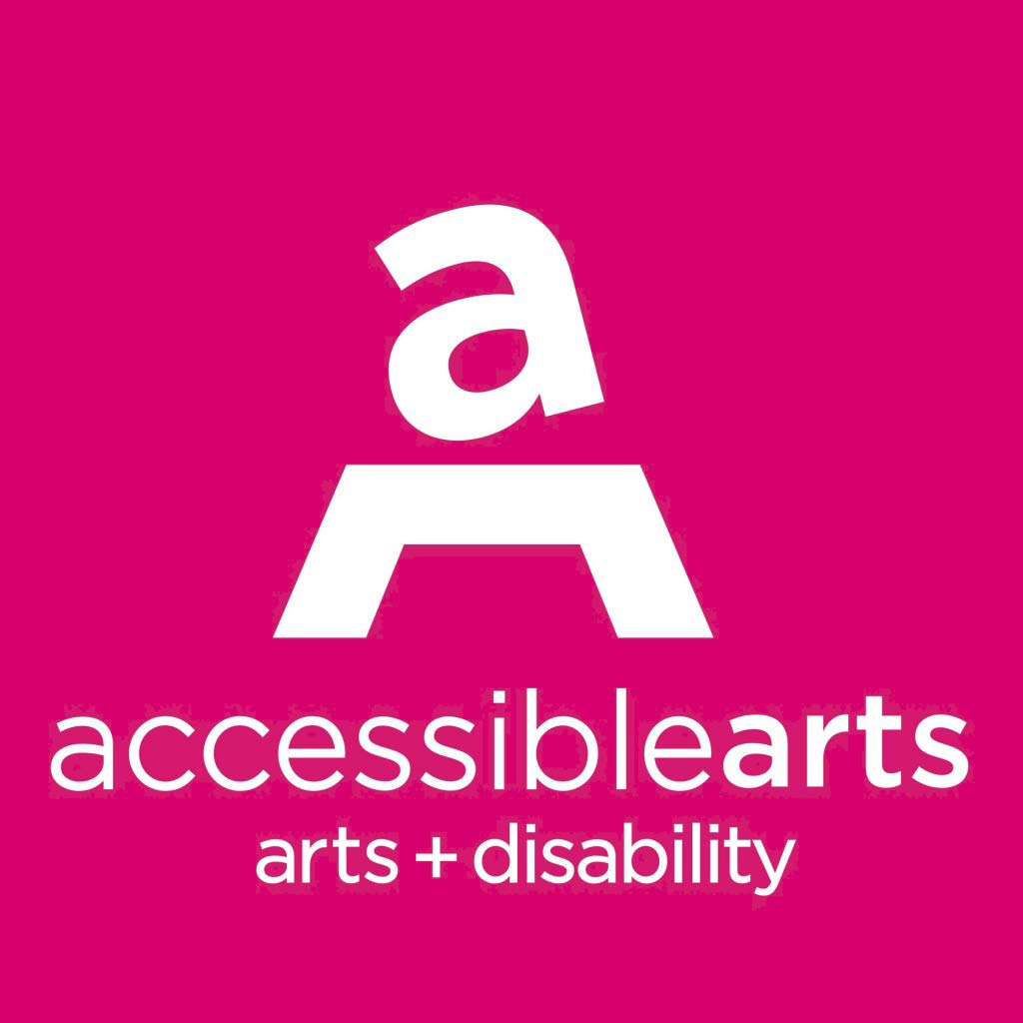
Position Description – Arts Development Manager

Details: Part-time (30 hours per week)
Reporting to: CEO
Reports: Front and Centre Project Coordinator
Disability and Culturally Diverse Internship Program Project Coordinator
Training Coordinator
Consultants
Volunteer Advisors
About Accessible Arts
Accessible Arts (AArts) is the peak arts and disability organisation in New South Wales. Established in 1986, we work with and for our community to accelerate and celebrate the diverse professional, cultural and social impacts of arts and disability in NSW. We advance the rights of, and opportunities for, people with disability and/or who are d/Deaf to develop and sustain professional careers in the arts and have equitable access to arts and culture across NSW. Our vision is equity and excellence in arts, culture and disability. More information is available online at www.aarts.net.au.

About The Position
The Arts Development Manager will be responsible for all aspects of developing and delivering a program of activities for AArts, in consultation with the CEO and the AArts team. These activities will enhance opportunities for people with disability to participate in quality creative activities across all artforms as arts practitioners and audiences.
- Contract position offering flexible working arrangements up to 30 hours per week.
- An attractive salary will be offered commensurate with experience and industry standards.
- This position reports to the CEO.
- Occasional evening and weekend work may be required to represent the organisation at external events and attend AArts events.
Position Responsibilities
The Arts Development Manager has responsibility for the following areas:

Program delivery - Work with the CEO and team to deliver a program of activity for 2023 as outlined in the Strategic Plan, including: In Conversation, Access: Ideas and Insights panel conversations, Advance Your Career professional development workshops, Bundanon Residency Program, Front and Centre Mentorship Program, Disability and Culturally Diverse Internship Program and Next Level Mentorship Program.

Partnerships – Broker and manage creative development collaborations, programs and relationships that will increase participation for arts practitioners with disability in the arts in NSW.

Advice and support – Provide ongoing support to artists with disability, including information about potential arts funding sources. Act as a referral point for all matters relating to inclusion and access to the arts across the state.

Fee for service work – Work with the CEO to further develop the Aarts consulting packages; identifying and securing fee for service work including Disability Inclusion Action Plans, Walk and Talk Access Audits, Website Audits and other access and inclusion opportunities. This role will also liaise with the Aarts contractor consultants and advisors used to deliver the fee for service work.

Promotion – Work with the Marketing Manager to ensure regular exposure of work and identify and build new partnerships between and within the arts and cultural sectors and the disability sector across the state.

Advocacy – Provide informed policy advice to the CEO as required. Coordinate and facilitate meetings with the Aarts Advisory team. Represent Aarts as and when required in community and sector forums.

Other duties as required.

Key Priorities 2023
For this current period, the following areas have been identified as priorities.

Programming and development: Work with the CEO and team to deliver a program of public activity for 2023 as outlined in the current strategic plan, including: In Conversation, Access: Ideas and Insights panel conversations, Advance Your Career professional development workshops.

Consulting: Oversee the delivery of consultancy services including Disability Inclusion Action Plans, Walk and Talk Access Audits and Website Audits. Identify and build new partnership opportunities within the arts and cultural sectors and the disability sector across the state. Work with the Marketing and Communications Manager and the CEO to explore new ways to grow our core client base and/or research opportunities for partnerships with arts organisations, cultural providers or government agencies that will expand our client base.

Advocacy: Work with the CEO and the Marketing and Development Manager to devise and implement strategies for further developing the role of AArts as the primary NSW advocacy body for the sector.

Key external relationships
Primary liaison with:
- arts and disability organisations in Sydney, regional NSW and ACT;
- national arts and disability network;
- arts workers; and
- artists with disability.

Some liaison may be required from time to time with:

- Corporate partners, sponsors, event suppliers, venues and funders.

