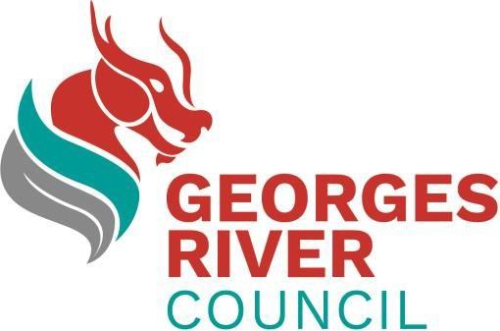

Disability Inclusion Action Plan

2022-2026

Art Competition
Guidelines

Expression of Interest
Artwork for Georges River Council’s Disability Inclusion Action Plan 2022-2026

Overview
Georges River Council is seeking submissions from emerging, mid-career or established artists who identify as being d/Deaf or a person with disability for an existing 2D artwork that can be used in the design of Council’s Disability Inclusion Action Plan (2022-2026). The timeframe would see the artwork delivered as high-resolution (300dpi minimum) images by 4 May 2022. The successful artist will receive $2000.

About Georges River
Georges River is home to a unique, rich and diverse community.
A higher proportion of residents are born overseas and speak a language other than English at home than the Greater Sydney average. There are particularly high proportions of people who speak Mandarin and Cantonese at home. Other languages spoken by Georges River residents other than English include Greek, Arabic and Nepali.
In 2016, 4.9% (or over 7,000 people) of the population in the Georges River local government area (LGA) reported needing help in their day-to-day lives, due to disability. As our population ages the number of people needing assistance is likely to increase. We are committed to creating a more inclusive community for all people who live, work and visit Georges River. This means ensuring all people with a disability and diverse needs have every opportunity to fully participate in and enjoy the social, business and community life of Georges River.
We have developed our Disability and Inclusion Action Plan to ensure actions that create a more inclusive and accessible community are embedded in Council’s services in a meaningful way.
The Disability and Inclusion Action Plan was developed through community consultation and outlines specific actions across four key focus areas:
- Developing positive attitudes and behaviours
- Creating liveable communities
- Supporting access to meaningful employment
- Improving access to services through better systems and processes.

Competition
Georges River Council is seeking submissions of existing 2D artworks that embody, connect or tell a story relating to one or more of the four key areas of the Disability and Inclusion Action Plan. The four key areas of the Disability and Inclusion Action Plan to which the artwork can relate to are:
- Positive attitudes & behaviour
- Creating liveable communities
- Better systems and processes
- Employment
The selected artwork will be incorporated into the Disability and Inclusion Action Plan document by Council’s Graphic Designer. A range of different media and styles will be considered. The artwork may be used in full and/or in part throughout the document.
The artist and artwork title will be acknowledged in the Disability and Inclusion Action Plan (2022-2026) document and the artist will be given opportunity to review the document proofs before publication.

Prize
The selected artist will be awarded a $2000 (ex. GST) prize, which includes provision of high-resolution images of the completed artwork, suitable for reproduction and /or publication. The high-resolution version must be provided to Georges River Council upon request.

Project schedule
Expressions of Interest open 14 April 2022
Expressions of Interest close 28 April 2022
Assessment panel 2 May 2022
Selected artist notified 2 May 2022
High resolution images of artwork received 4 May 2022

Application and selection process

Stage 1
Artists are invited to submit an entry via Survey Monkey on the Accessible Arts website. Artwork entries can also be submitted by alternative accessible formats including PDF and Word Document.
Artists will be asked to provide the following information:
- A short artist’s bio
- Images of up to three works to be submitted for consideration
- Name of artwork, medium, description of artwork and how it relates to the four key areas of the Disability and Inclusion Action Plan

Artists who submit an artwork for this competition may be kept on file by Accessible Arts and Georges River Council’s Hurstville Museum and Gallery and may be called on for future art projects.

Stage 2
A selection panel, consisting of three Georges River Council Officers, will select the final artwork for Council’s Disability and Inclusion Action Plan (2022-2026).

Stage 3
The successful artist will be notified by Georges River Council of their selection and provided with the artist agreement and payment forms. Photos of the selected artwork/s and artist credit may be published on the Georges River Council and Accessible Arts websites as well as across social media platforms.
The artist will provide Georges River Council with high resolution images (minimum 300 dpi) for use by Council in the design of the Disability and Inclusion Action Plan (2022-2026) within the specified timeline.

Selection criteria
Artworks submitted in Stage 1 will be assessed against the following criteria:
- Alignment to one or more of the four key areas of the Disability and Inclusion Action Plan (2022-2026)
- Artistic merit and originality of design
- Overall impression of the artwork and the ability to translate into printed materials for the purpose of Council

Questions?
If you have any questions about this competition, please contact:
Georges River Council: Skadi Nova, Coordinator Community Capacity Building snova@georgesriver.nsw.gov.au
Accessible Arts: info@aarts.net.au

