About ArtScreen 2022

ABOUT ARTSCREEN 2022

ArtScreen 2022 is a visual art project which seeks to enable two (2) NSW artists with disability to develop their creativity and careers by developing an innovative new work in the format of video art.

The successful applicants will be mentored by an experienced video artist to create video artworks up to 10 minutes duration which explore themes of identity, access and social connectedness. Artworks are required to be produced in accessible formats including captioning, audio description and Auslan interpretation.

WHO CAN APPLY

Applicants must identify as being d/Deaf or a person with disability
- Applicants must be emerging or mid-career visual artist and/or filmmakers

Applicants must reside in NSW
- Applicants do not need to have prior experience working with video as a creative format

PERSONAL DETAILS

First Name

Last Name

CONTACT INFORMATION

Address

Address 2

City/Town

State

Post Code

Email Address

Phone Number

ARE YOU OVER 18 YEARS OF AGE
Yes No

HOW DO YOU IDENTIFY? (Select as many as you like)
First Nations (Australia) First Nations (other)
Culturally and linguistically diverse Person with disability
d/Deaf hard of hearing Person with chronic pain
Person with mental health condition LGBTQIA+
Living in Western Sydney Living in regional NSW
Having experience of socio-economic disadvantage Under 25
Over 65

Other (please specify)

GENDER: How do you identify?
Female Male
Non-Binary
Self-describe, below

ACCESS

Do you have any access requirements? Please list your requirements, e.g. Auslan, captioning, etc. Please be very detailed and specific in your response

How did you hear about ArtScreen?
Accessible Arts e-news Accessible Arts website Facebook
Instagram Word of Mouth
Other (please specify)

Artist Bio/CV

Please Upload your Bio/CV

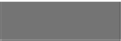
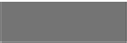
No file chosen
Choose File
Choose File

Your ArtScreen 2022 Project Proposal

- 9. Title

10. Creative Concept

Please include the following details:

Your idea for the artwork
How your proposal explores and responds to the themes of identity, access and social connection How you imagine working with mentor Dr Zanny Begg
(500 words maximum)

- 11. What artistic outcomes are you hoping to achieve with this project? (200 words maximum)

- 12. How do you think this project will advance your career as a professional artist? (200 words maximum)

- 13. Your Budget

In this section please provide a basic breakdown of how you will use the available budget and in-kind resources to produce your artwork.

The production budget that’s available is as follows:

- Artist Fee: $3000 (cash)

- Production expenses: $7000 (cash)

- Production equipment and post-production facilities: $7000 (in-kind from ACE)

- Production assistants: $2000 (in-kind from Bus Stop Films)

- Artwork access costs (e.g. captioning, audio description, Auslan): $1500 (cash)

Applicants are welcome to use the project’s cash component to cover any relevant project expenses (e.g. cast, crew, production design, equipment, travel, access, etc).

ACE equipment includes video cameras, stills cameras, lighting kits, microphones, audio recorders and tripods. ACE post-production facilities include video editing suites, audio recording studios and a green screen room.

Below is an ACE price guide to assist with budgeting. Please contact ACE directly to make any specific enquiries about equipment and facilities. https://ice.org.au/contact/

Category | Rate
Editing Suite (Mac Pro | Final Cut | Premiere) | $140/day
Audio Suite (Mac Pro | Logic Pro | Ableton) | $140/day
Canon 5D (stills camera) | $130
Sony Ex3 (video camera) | $150
Zoom H6N (audio recorder) | $30
Dedo Lights (big lights) | $60
Redhead (medium lights) | $40
Litepanel (small lights) | $40

Two (2) students from Bus Stop Films, Accessible Film Studies Program may be engaged to work alongside the artists and provide up to 12 hours of general assistance during the pre-production and production phases of the project. This will be dependent on the location of the project and student availability. If necessary, support workers for the students may be supplied with costs met by the project.

Applicants are welcome to augment their budget with other sources of funding (such as money or in-kind support from individuals or businesses, NDIS funding for relevant access requirements, etc). These sources must be detailed in the budget.

All final artworks must be delivered in multiple formats which include captioning, audio description and Auslan interpretation. There is $1500 in the production budget to cover these costs.

Please provide any production budget notes here (optional, 200 words maximum)

14. Budget Template & Sample Budget

You can access a budget template and sample budget here: www.aarts.net.au/artscreen2022

Please upload your production budget

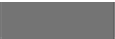
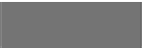
No file chosen
Choose File
Choose File

15. SUPPORTING MATERIALS

In this section please include information which supports the creative concept for your project specifically or for your application generally.

Supporting materials may include:

- Up to 5 images of artwork (pictures, drawings, sketches, photographs, etc)

- Up to 5 minutes of videography, film or visual story

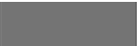
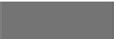
- Up to 5 minutes of audio recording (music, voiceover, etc) Attach a file
Choose File
Choose File
No file chosen

Supporting Materials



No file chosen
Choose File
Choose File

Supporting Materials



No file chosen
Choose File
Choose File

Supporting Materials



No file chosen
Choose File
Choose File

Supporting Materials



No file chosen
Choose File
Choose File

Supporting Materials



No file chosen
Choose File
Choose File

Supporting Materials

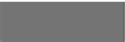
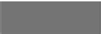
No file chosen
Choose File
Choose File

Supporting Materials

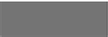
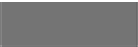
No file chosen
Choose File
Choose File

Supporting Material

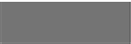
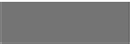
No file chosen
Choose File
Choose File

Supporting Material

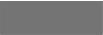
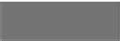
No file chosen
Choose File
Choose File

Supporting Material

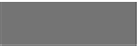
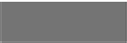
No file chosen
Choose File
Choose File

Supporting Material

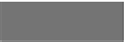
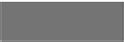
No file chosen
Choose File
Choose File

Supporting Material

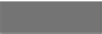
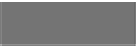
No file chosen
Choose File
Choose File

Supporting Material

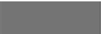
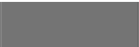
No file chosen
Choose File
Choose File

Supporting Material


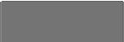
No file chosen
Choose File
Choose File

