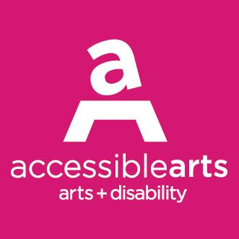

ARTSCREEN 2022 APPLICATION GUIDELINES

1. ABOUT ARTSCREEN 2022

ArtScreen 2022 is a visual art project which seeks to enable two (2) NSW artists with disability to develop their creativity and careers by developing and innovative new work in the format of video art.

The successful applicants will be mentored by an experienced video artist to create video artworks up to 10 minutes duration which explore themes of identity, access and social connectedness. Artworks are required to be produced in accessible formats including captioning, audio description and Auslan interpretation.

All completed artworks will be premiered in all accessible versions in the Veolia Lecture Theatre at the Museum of Contemporary Art (MCA) in Sydney. A launch event will take place on the evening of Friday December 2, followed by a live Q&A with the artists on Saturday December 3, marking the International Day of People with Disability. The works will be screened at the MCA in the Veolia Lecture Theatre from Friday December 2 – Sunday December 4.

ArtScreen is funded with grants from Create NSW and the City of Sydney as well as in-kind contributions from Accessible Arts, MCA, Bus Stop Films and Parramatta’s Arts & Cultural Exchange (A.C.E, formerly I.C.E) This is the third year of this exciting project.

2. WHO CAN APPLY

- Applicants must identify as being d/Deaf or a person with disability
- Applicants must be emerging or mid-career visual artists and/or filmmakers
- Applicants must reside in NSW
- Applicants do not need to have prior experience working with video as a creative format

3. PROJECT REQUIREMENTS

- Artworks must explore the themes of identity, access and social connectedness
- Artworks should engage with experimental video forms and advance visual/cinematic language
- All final artworks must be delivered in multiple formats which include captioning, audio description and Auslan interpretation. Applicants are expected to plan for the integration of accessible elements from the earliest stages of development. A budget is provided to facilitate this.
- Artworks should have a minimum duration of 3 minutes and a maximum duration of 10 minutes
- Applicants must demonstrate that they can create and deliver their artwork using the funds and in-kind resources that comprise the project budget
- Applicants must be available to commence production of the artwork from April 2022 and deliver the final artwork by October 2022
- Applicants must work with the project mentor
- Successful applicants will be required to attend disability and access training at the commencement of the program

4. MENTOR

The successful applicant will receive up to 15 hours of support from video artist Dr Zanny Begg. Zanny will be available for an initial consultation and then will provide advice and support during pre-production, production and post-production.
Dr Zanny Begg
Zanny is an artist, curator, theorist and lecturer at UNSW Art and Design. As an artist, Zanny is interested in hidden and contested history/ies. She works with film, drawing and installation to explore ways in which we can live and be in the world differently. https://zannybegg.com/

5. ACCESS

Applicants are welcome to detail if they have any access requirements and how these requirements will be addressed during the production process.

Any access requirements must be funded out of the $7000 cash component of the project budget OR through other funding mechanisms, such as the NDIS.

For example, if the applicant requires a camera operator, the cost of this could be met using part of the $7000 cash component. However, if the applicant requires an Auslan interpreter for any part of the production process, the cost of this could potentially be met using NDIS funding.

Please contact us if you have any questions about access requirements.

ArtScreen guidelines and application forms are available in accessible formats upon request. Formats include word documents, audio files, and large print.

6. PROJECT BUDGET AND SUPPORTS

Production can be supported by a team of students from inclusive screen production school Bus Stop Films, Accessible Film Studies Program and with equipment/facilities from Parramatta’s Arts & Cultural Exchange (A.C.E, formerly I.C.E).

The available production budget is as follows:

ITEM | $
Artist Fee | $3000 (cash)
Production expenses | $7000 (cash)
Production equipment and post-production facilities from A.C.E | $7000 (in-kind)
Production assistants (from Bus Stop Films) | $2000 (in-kind)
Artwork access costs (captioning, audio description, Auslan) | $1500 (cash)
TOTAL | $20,500

Applicants are welcome to use the project’s cash component to cover any relevant project expenses (cast, crew, production design, equipment, travel, access, etc).

A.C.E equipment includes video cameras, stills cameras, lighting kits, microphones, audio recorders and tripods. A.C.E post-production facilities include video editing suites, audio recording studios and a green screen room.

Below is an A.C.E price guide to assist with budgeting. Please contact A.C.E. directly to make any specific enquiries about equipment and facilities.

Category | Rate
Editing Suite (Mac Pro | Final Cut | Premiere) | $140/day
Audio Suite (Mac Pro | Logic Pro | Ableton) | $140/day
Canon 5D (stills camera) | $130
Sony Ex3 (video camera) | $150
Zoom H6N (audio recorder) | $30
Dedo Lights (big lights) | $60
Redhead (medium lights) | $40
Litepanel (small lights) | $40

Two (2) students from Bus Stop Films, Accessible Film Studies Program may be engaged to work alongside the artists and provide up to 12 hours of general assistance during the pre-production and production phases of the project. This will be dependent on the location of the project and student availability. If necessary, support workers for the students may be supplied with costs met by the project.

Applicants are welcome to augment their budget with other sources of funding (e.g. cash or in-kind support from individuals or businesses, NDIS funding for relevant access requirements, etc). These sources must be detailed in the final budget.

All final artworks must be delivered in all accessible formats which include captioning, audio description and Auslan interpretation. There is $1500 in the production budget to cover these costs.

Budget Template & Sample Budget

You can access a budget template and sample budget here.

7. SELECTION CRITERIA & PROCESS

Applications will be assessed using the following criteria:
- Artistic standing of the applicant
- Creative merit of the project concept
- Benefit of the project to the applicant’s professional development
- Ability to deliver the project on time and on budget
- Suitability of the project for Prototype programming

Applications will be assessed by a panel including the mentor, Accessible Arts staff and other industry experts.

All applicants will be notified of the results in May 2022.

Successful applicants will be required to enter into an agreement which will contain additional terms and conditions in accordance with existing policies of Accessible Arts, MCA, Prototype, Bus Stop Films and A.C.E.

The successful applicant must provide Accessible Arts and the MCA with permission to screen and share the artwork created through the ArtScreen initiative. This will include a 3-day screening in the MCA’s Veolia Lecture Theatre from December 2-4, 2022.

If selected by Prototype, an agreement will then be made between Prototype and the successful artist in relation to an online exhibition.

For the purposes of promoting ArtScreen, the successful applicant must also agree to make themselves available for interviews, filming and other social media opportunities.

8. WHEN TO APPLY

Applications close at midnight on Tuesday 26 April 2022.

9. HOW TO APPLY

Applications can be made via Survey Monkey here.
In the application, you will be asked to provide the following:

Artist Bio
- Your Artist biography, qualifications and CV

Creative Concept (max. 500 words)
- Your idea for the artwork
- How your proposal explores and responds to the themes of identity, access and social connectedness.
- How you envisage working with the mentor

Project Budget
- A basic breakdown of how you will use the available budget and in-kind resources to produce your artwork.
- You can download a budget template here.

Supporting Materials (any of the below)
- Up to 5 images of artwork (pictures, drawings, sketches, photographs, etc)
- Up to 5 minutes of videography, film or visual story
- Up to 5 minutes of audio recording (music, voiceover, etc)

ArtScreen guidelines and application forms are available in accessible formats upon request. Formats include word documents, audio files, and large print. Please contact Accessible Arts staff if you would like to submit your application in an alternate format.

10. ENQUIRES

Please direct any enquiries to Anthea Williams, Accessible Arts Project Coordinator:
Email: awilliams@aarts.net.au
Phone: (02) 9251 6499

This project is supported by:

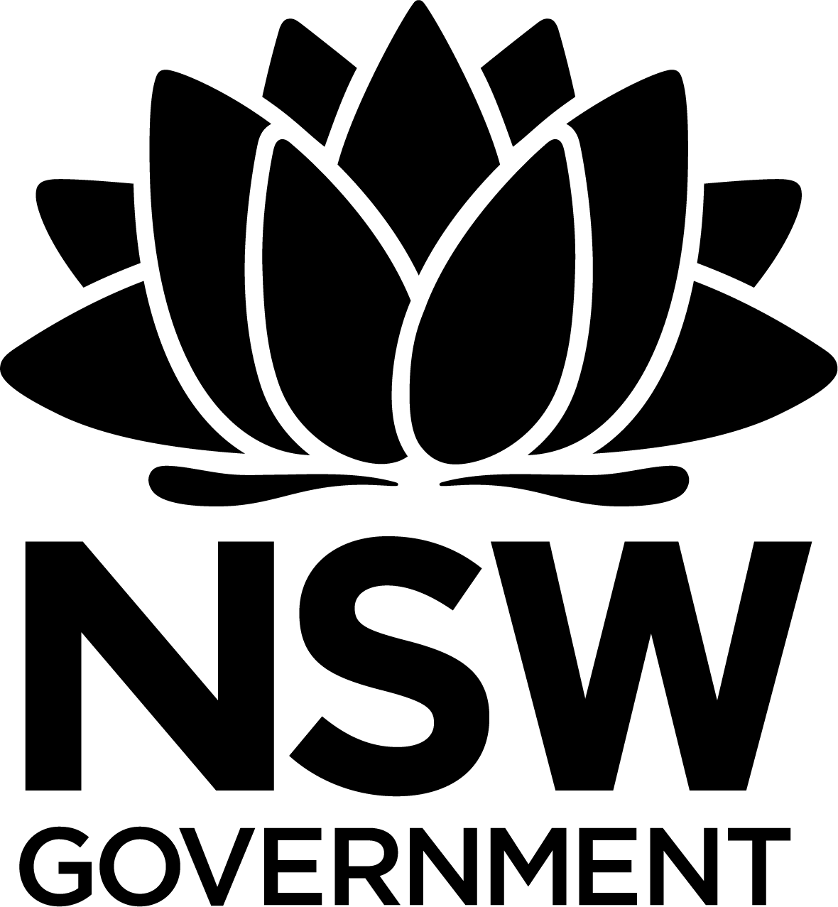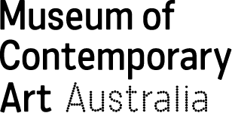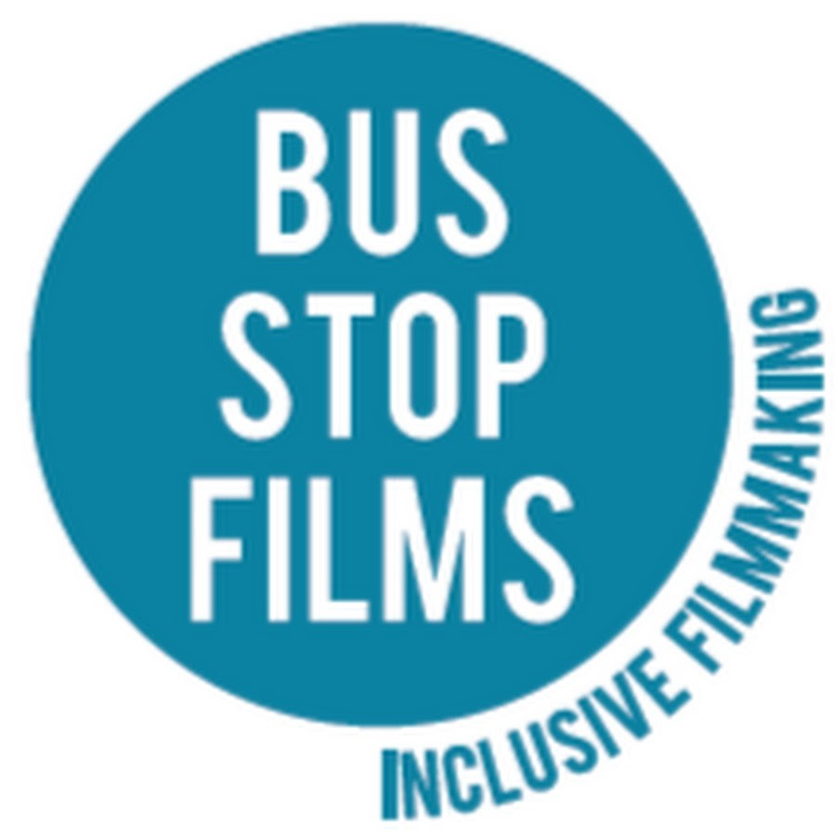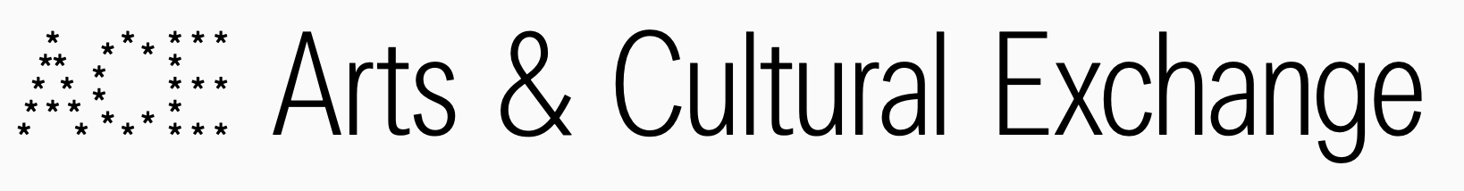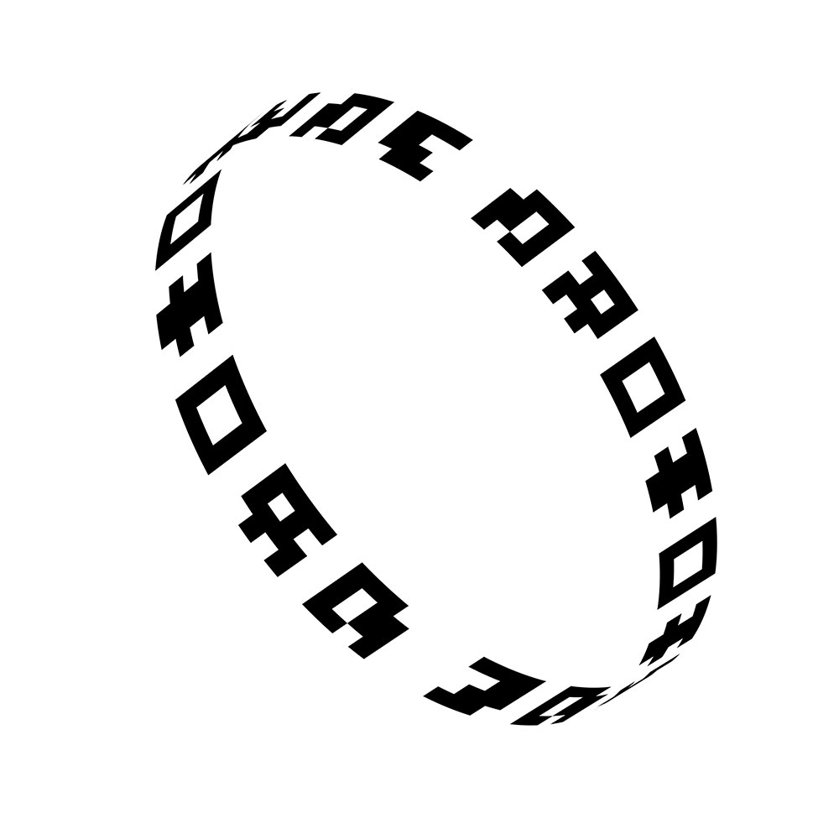

ENDS

