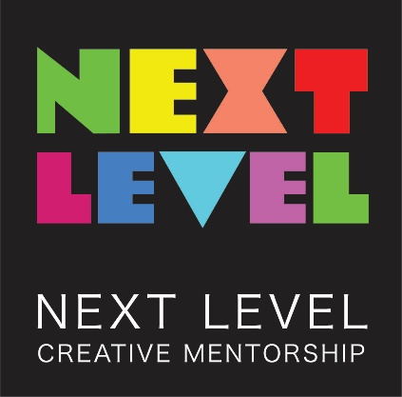

Next Level Creative Mentorship Guidelines

The Next Level Creative Mentorship Program will provide five (5) artists with access to a mentorship within a leading performing arts organisation and $5000 in project funding to develop an innovative new project. Writers, musicians, dancers, choreographers, actors, directors, and/or producers are invited to apply for this opportunity.

Mentorships will take place within one of our partnering organisations that include Brand X, Darlinghurst Theatre Company, Musica Viva, Northern Rivers Performing Arts, PACT, Riverside Parramatta, Sydney Dance Company and Sydney Theatre Company.
The mentorship will result in the opportunity to pitch your idea to relevant companies, venues, artistic directors and/or producers. This is a hybrid program with both professional and project development outcomes.

Over a period of three months, the mentor will work with you to:

- Assess your idea
- Develop your idea into a concept brief
- Provide advice on drafting a detailed project outline based on the concept brief
- Assist with securing pitch meetings with relevant companies, venues, artistic directors and/or producers

The successful applicant will receive up to 20 hours of one-to-one support from a selected staff member within our Partnering Organisations. This will include support to develop a concept brief and facilitating networking opportunities and pitch meetings.

The program will involve facilitated sessions with your mentor and self-directed tasks. Suitable scheduling will be negotiated between you and the mentor.

The Next Level Creative Mentorship Program will be undertaken and completed between March-June 2022.

Partnering Organisations

Next Level is supported by grants from the NSW Government through Create NSW and in-kind contributions from Accessible Arts and our supporting organisations:

- Brand X
- Darlinghurst Theatre Company
- Musica Viva
- Northern Rivers Performing Arts
- PACT
- Riverside Parramatta
- Sydney Dance Company
- Sydney Theatre Company

Who can apply?

- Applicants must identify as being d/Deaf or a person with disability
- Applicants may be an emerging, mid-career or professional writer, actor, musician, dancer, choreographer, director and/or producer
- Applicants must reside in NSW
- Applicants must have previous experience at any level in the arts sector

Access
Applicants will need to provide information on their access requirements via the application form. The partnering organisations will be provided with customised Disability Confidence Training facilitated by Accessible Arts. Both the interns and Host organisations will receive support from Accessible Arts throughout the duration of the mentorship program.

The Next Level Creative Mentorship guidelines and application forms are available in accessible formats upon request. Formats include word documents, audio files, and large print.

Application Information

Applicants will be asked to provide the following information:

- Contact Details
- CV or short bio – including examples of relevant work, volunteer and study experience and/or qualifications
- Do you identify as a person with disability or d/Deaf? Yes/No
- Outline any support and/or access requirements you may have
- Outline your previous work, professional and/or volunteer experience as it relates to this opportunity

- Summary of your formal or informal training and employment
- Identify the field of your practice (writer, musician, dancer, choreographer, actor, director and/or producer)
- Describe the idea that you would like to develop during the Mentorship Program
- Identify one or more of the partnering organisations listed in these guidelines that you are interested in working with
- Provide the details of two independent referees who can speak to your suitability for this program

Successful applicants will be required to enter into an agreement which will contain additional terms and conditions in accordance with existing policies of Accessible Arts. The successful applicant must provide Accessible Arts permission to promote and/or share the outcomes of the Next Level Creative Mentorship Program.

For the purposes of promoting Next Level, the successful applicant must also agree to make themselves available for interviews, filming and other social media opportunities.

How to Apply

Applications can be made online via Survey Monkey at:

There are also Word and PDF application forms available on the Accessible Arts website:

Applications will also be accepted in other formats that are accessible to the applicant including Auslan, audio, video, printed, dictated, electronic and handwritten formats.

Applications are now open and close Monday 31 January 2022 at 5pm.

Applications will be assessed by a panel of Accessible Arts staff, including people with disability. Shortlisted applicants will progress to an interview stage before final selection of the mentees are made. Interviews will be facilitated by Accessible Arts with staff from partnering organisations also in attendance.

Enquiries

Please direct enquiries to: Marika Perrow, Arts Development Manager, Accessible Arts.
Email: mperrow@aarts.net.au

