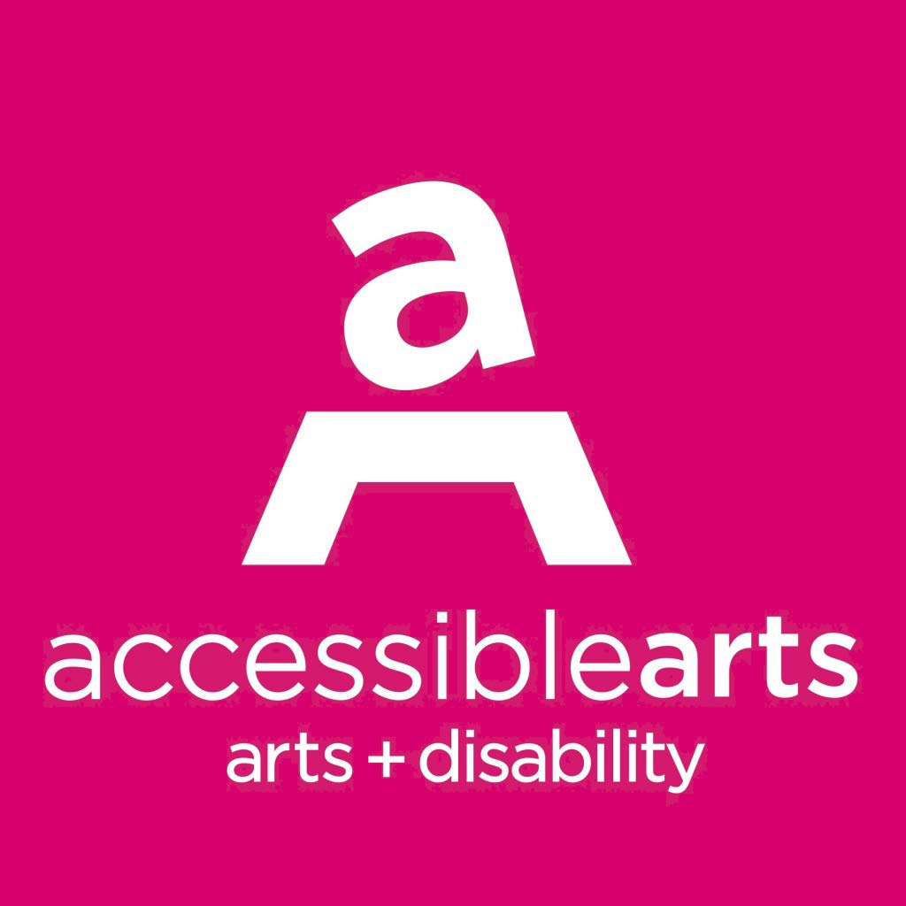

Accessible Arts
Position Description – Arts Development Manager

Details: Part-time, nine-month contract (30 hours per week)
Reporting to: CEO
Reports: ArtScreen Project Officer
Trainers
Consultants
Volunteer Advisors

About Accessible Arts
Accessible Arts (AArts) is the peak arts and disability organisation in New South Wales. Established in 1986, we work with and for our community to accelerate and celebrate the diverse professional, cultural and social impacts of arts and disability in NSW. We advance the rights of, and opportunities for, people with disability and/or who are d/Deaf to develop and sustain professional careers in the arts and have equitable access to arts and culture across NSW. Our vision is equity and excellence in arts, culture and disability. More information is available online at www.aarts.net.au.

About The Position
The Arts Development Manager will be responsible for all aspects of developing and delivering a program of activities for AArts, in consultation with the CEO and the AArts team. These activities will enhance opportunities for people with disability to participate in quality creative activities across all artforms as arts practitioners and audiences.
- Contract position offering flexible working arrangements up to 30 hours per week.
- An attractive salary will be offered commensurate with experience and industry standards.
- This position reports to the CEO.
- Occasional evening and weekend work may be required to represent the organisation at external events and attend AArts events.
Position Responsibilities
The Arts Development Manager has responsibility for the following areas:

Program delivery - Work with the CEO and team to deliver a program of activity for 2021-2022 as outlined in the Strategic Plan, including: In Conversation, ATAG, ArtScreen, Bundanon Residency Program, Sydney Olympic Park Authority Residency Program, Professional Development workshops, Createability Internship Program, Front and Centre Mentorship Program and Next Level.

Partnerships - Broker and manage creative development collaborations, programs and relationships that will increase participation for arts practitioners with disability in the arts in NSW.

Advice and support - Provide ongoing support to artists with disability, including information about potential arts funding sources. Act as a referral point for all matters relating to inclusion and access to the arts across the state.

Fee for service work - Work with the CEO to further develop the AArts training and consulting packages; identifying and securing fee for service work including general and bespoke training, Disability Inclusion Action Plans, Walk and Talk Access Audits, Website Audits and other access and inclusion opportunities. This role will also liaise with the AArts contractor consultants and advisors used to deliver the fee for service work. This role will also oversee the delivery of an agreed schedule of training programs across the state, as well as supervising the pool of casual trainers, monitor their presentations, provide feedback and further training if required.

Promotion - Work with the Marketing Manager to ensure regular exposure of work and identify and build new partnerships between and within the arts and cultural sectors and the disability sector across the state.

Advocacy – Provide informed policy advice to the CEO as required. Coordinate and facilitate meetings with the AArts Advisory team. Represent AArts as and when required in community and sector forums.

Other duties as required.

Key Priorities 2021/2022
For this current period, the following areas have been identified as priorities.

Programming and development: Work with the CEO and team to deliver a program of activity for 2021-2022 as outlined in the current strategic plan, including: In Conversation, ATAG, Bundanon Residency Program, ArtScreen, Sydney Olympic Park Authority Residency Program, Professional Development workshops.

Training: Oversee the delivery of both general and bespoke training packages. Supervise and engage pool of casual trainers. Work with the Marketing and Communications Manager and the CEO to promote and set goals for 2021 and 2022.

Consulting: Oversee the delivery of consultancy services including Disability Inclusion Action Plans, Walk and Talk Access Audits and Website Audits. Identify and build new partnership opportunities within the arts and cultural sectors and the disability sector across the state. Work with the Marketing and Communications Manager and the CEO to explore new ways to grow our core client base and/or research opportunities for partnerships with arts organisations, cultural providers or government agencies that will expand our client base.

Advocacy: Work with the CEO and the Marketing and Development Manager to devise and implement strategies for further developing the role of AArts as the primary NSW advocacy body for the sector.

Key external relationships
Primary liaison with:

- arts and disability organisations in Sydney, regional NSW and ACT;
- national arts and disability network;
- arts workers; and
- artists with disability.

Some liaison may be required from time to time with:

- Corporate partners, sponsors, event suppliers, venues and funders.

Selection criteria
Essential
- Demonstrated knowledge of arts, cultural and community networks in NSW, ACT and nationally;
- Demonstrated knowledge of arts and disability practice and artists with disability;
- Knowledge of government policies and trends relevant to the arts and disability;
- Knowledge and experience delivering training and/or managing projects;
- Strong relationship management, partnership development and negotiation skills;
- Demonstrated arts management experience e.g. grant application and acquittal process, committee management and report writing; and
- Knowledge of the disability sector, including access and inclusion principles.

Desired

- Identify as someone with lived experience of disability or who is d/Deaf;

** Position description current as at August 2021. This document will be reviewed on a regular basis and changes made to reflect changes in the requirements of the role.

